**1.Problem Statement - Display Employee List and Edit Employee form using RESTful Web Service**

**EmployeeController**

package com.example.controller;

import com.example.model.Employee;

import com.example.service.EmployeeService;

import org.springframework.beans.factory.annotation.Autowired;

import org.springframework.web.bind.annotation.*;

import java.util.List;

@RestController

@CrossOrigin(origins = "*")

@RequestMapping("/api/employees")

public class EmployeeController {

@Autowired

private EmployeeService employeeService;

@GetMapping

public List<Employee> getAllEmployees() {

return employeeService.getAllEmployees();

}

@GetMapping("/{id}")

public Employee getEmployeeById(@PathVariable int id) {

return employeeService.getEmployeeById(id);

}

}

**EmployeeDao**

package com.example.dao;

import com.example.model.Employee;

import org.springframework.context.support.ClassPathXmlApplicationContext;

import org.springframework.stereotype.Repository;

import java.util.List;

@Repository

public class EmployeeDao {

private List<Employee> employeeList;

public EmployeeDao() {

ClassPathXmlApplicationContext context = new ClassPathXmlApplicationContext("employee-config.xml");

employeeList = (List<Employee>) context.getBean("employeeList");

}

public List<Employee> getAllEmployees() {

return employeeList;

}

public Employee getEmployeeById(int id) {

return employeeList.stream().filter(e -> e.getId() == id).findFirst().orElse(null);

}

**}**

**Employee**

package com.example.model;

public class Employee {

private int id;

private String name;

private String department;

public Employee() {}

public Employee(int id, String name, String department) {

this.id = id;

this.name = name;

this.department = department;

}

public int getId() {

return id;

}

public void setId(int id) {

this.id = id;

}

public String getName() {

return name;

}

public void setName(String name) {

this.name = name;

}

public String getDepartment() {

return department;

}

public void setDepartment(String department) {

this.department = department;

}

}

**EmployeeService**

package com.example.service;

import com.example.dao.EmployeeDao;

import com.example.model.Employee;

import org.springframework.beans.factory.annotation.Autowired;

import org.springframework.stereotype.Service;

import java.util.List;

@Service

public class EmployeeService {

@Autowired

private EmployeeDao employeeDao;

public List<Employee> getAllEmployees() {

return employeeDao.getAllEmployees();

}

public Employee getEmployeeById(int id) {

return employeeDao.getEmployeeById(id);

}

} 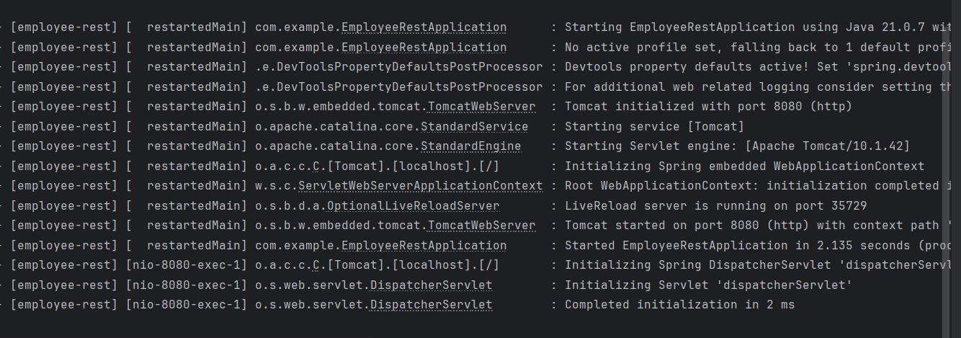

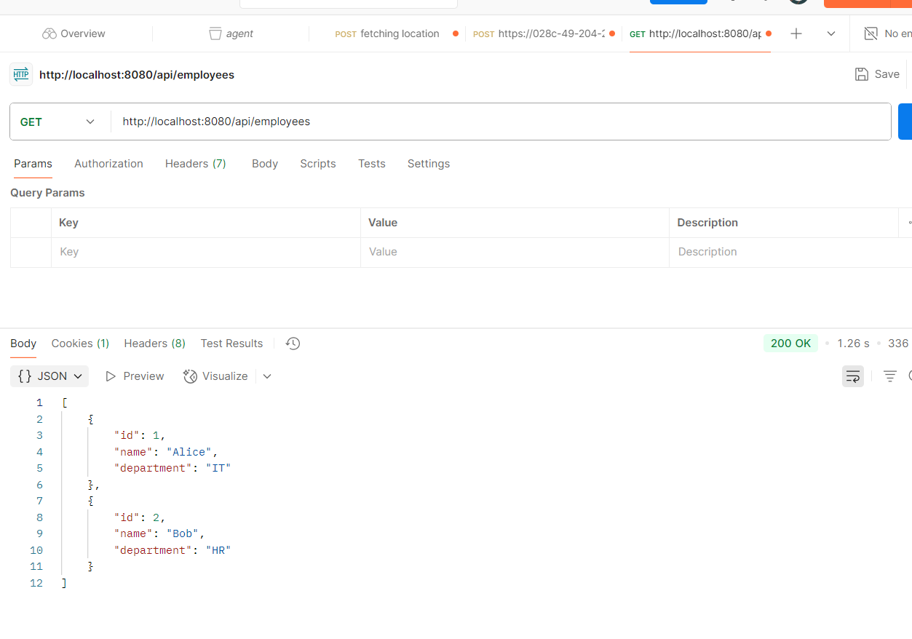

**2.Create static employee list data using spring xml configuration** 

**Employee.java**

package com.example.model;

import java.util.List;

public class Employee {

private int id;

private String name;

private String email;

private Department department;

private List<Skill> skills;

public int getId() {

return id;

}

public void setId(int id) {

this.id = id;

}

public String getName() {

return name;

}

public void setName(String name) {

this.name = name;

}

public String getEmail() {

return email;

}

public void setEmail(String email) {

this.email = email;

}

public Department getDepartment() {

return department;

}

public void setDepartment(Department department) {

this.department = department;

}

public List<Skill> getSkills() {

return skills;

}

public void setSkills(List<Skill> skills) {

this.skills = skills;

}

}

**Department.java**

package com.example.model;

public class Department {

private int id;

private String name;

public int getId() {

return id;

}

public void setId(int id) {

this.id = id;

}

public String getName() {

return name;

}

public void setName(String name) {

this.name = name;

}

}

**Skill.java**

package com.example.model;

public class Skill {

private int id;

private String name;

public int getId() {

return id;

}

public void setId(int id) {

this.id = id;

}

public String getName() {

return name;

}

public void setName(String name) {

this.name = name;

}

}

**EmployeeController**

package com.example.controller;

import com.example.model.Employee;

import com.example.service.EmployeeService;

import org.springframework.web.bind.annotation.*;

import java.util.List;

@RestController

public class EmployeeController {

private final EmployeeService employeeService;

public EmployeeController(EmployeeService employeeService) {

this.employeeService = employeeService;

}

@GetMapping("/employees")

public List<Employee> getAllEmployees() {

return employeeService.getAllEmployees();

}

}

**EmployeeDao**

package com.example.dao;

import com.example.model.*;

import org.springframework.stereotype.Repository;

import java.util.Arrays;

import java.util.List;

@Repository

public class EmployeeDao {

public List<Employee> getAllEmployees() {

Department it = new Department();

it.setId(1);

it.setName("IT");

Skill java = new Skill();

java.setId(1);

java.setName("Java");

Skill spring = new Skill();

spring.setId(2);

spring.setName("Spring");

Employee e1 = new Employee();

e1.setId(101);

e1.setName("Alice");

e1.setEmail("alice@example.com");

e1.setDepartment(it);

e1.setSkills(Arrays.asList(java, spring));

Employee e2 = new Employee();

e2.setId(102);

e2.setName("Bob");

e2.setEmail("bob@example.com");

e2.setDepartment(it);

e2.setSkills(List.of(java));

return List.of(e1, e2);

}

}

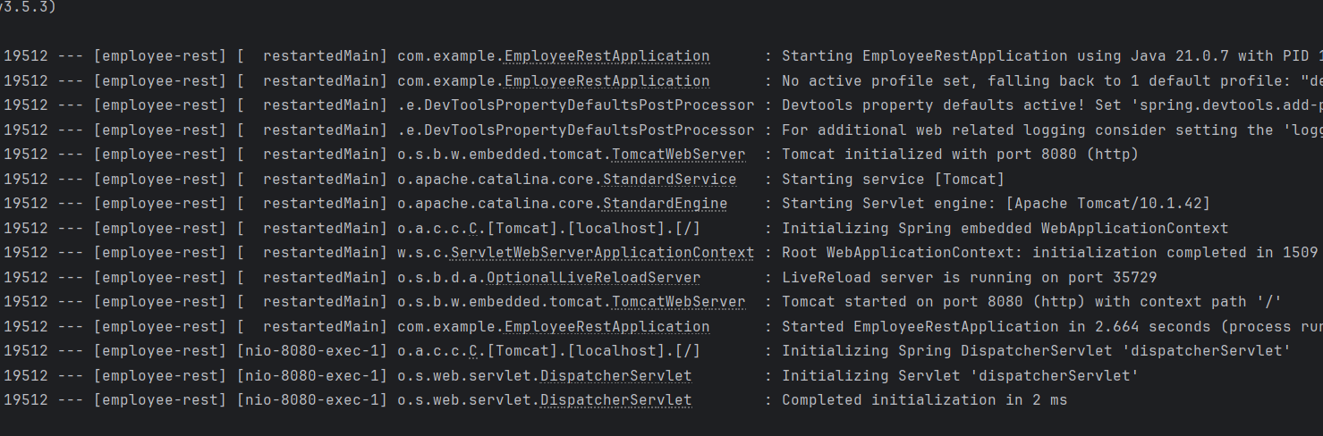 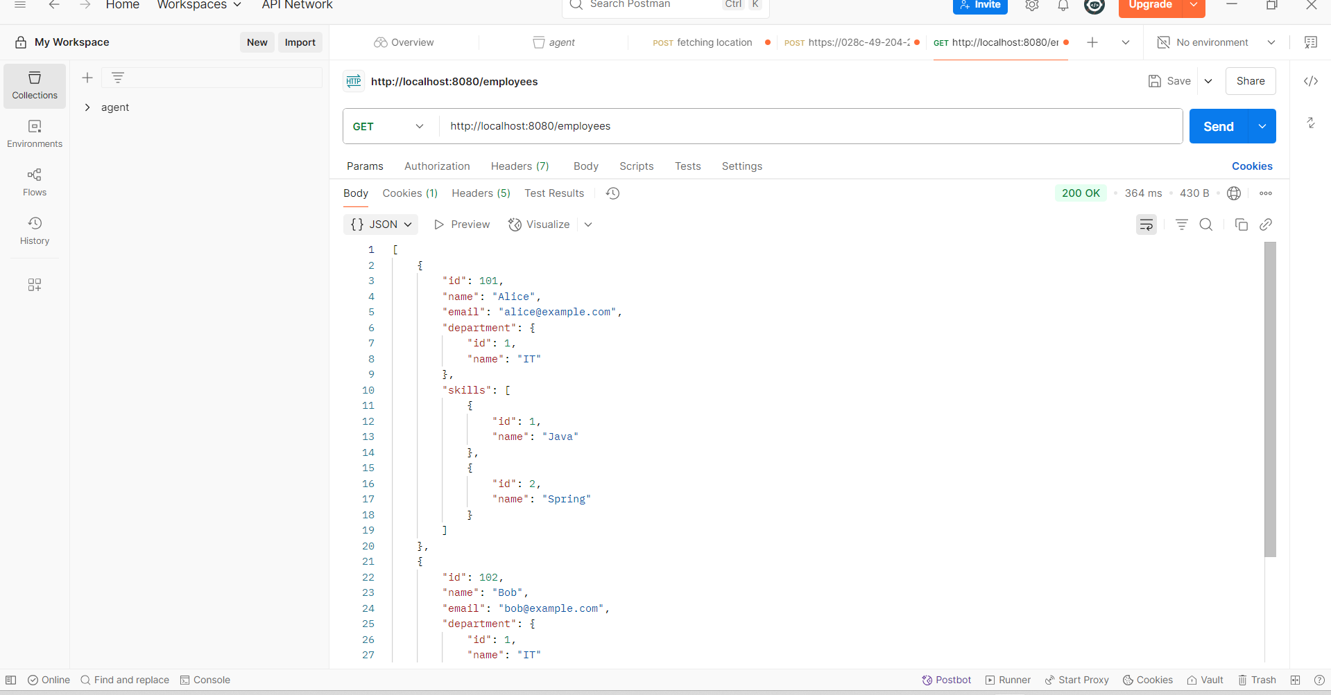

**3.Create REST service to gets all employees**   
  
**Employee.java**

package com.example.model;

public class Employee {

private int id;

private String name;

private String email;

public int getId() {

return id;

}

public void setId(int id) {

this.id = id;

}

public String getName() {

return name;

}

public void setName(String name) {

this.name = name;

}

public String getEmail() {

return email;

}

public void setEmail(String email) {

this.email = email;

}

}

**EmployeeDao**

package com.example.dao;

import com.example.model.Employee;

import org.springframework.stereotype.Repository;

import java.util.Arrays;

import java.util.List;

@Repository

public class EmployeeDao {

public List<Employee> getAllEmployees() {

Employee e1 = new Employee();

e1.setId(1);

e1.setName("Alice");

e1.setEmail("alice@example.com");

Employee e2 = new Employee();

e2.setId(2);

e2.setName("Bob");

e2.setEmail("bob@example.com");

return Arrays.asList(e1, e2);

}

}

**EmployeeController**

package com.example.controller;

import com.example.model.Employee;

import com.example.service.EmployeeService;

import org.springframework.web.bind.annotation.*;

import java.util.List;

@RestController

public class EmployeeController {

private final EmployeeService employeeService;

public EmployeeController(EmployeeService employeeService) {

this.employeeService = employeeService;

}

@GetMapping("/employees")

public List<Employee> getAllEmployees() {

return employeeService.getAllEmployees();

}

}

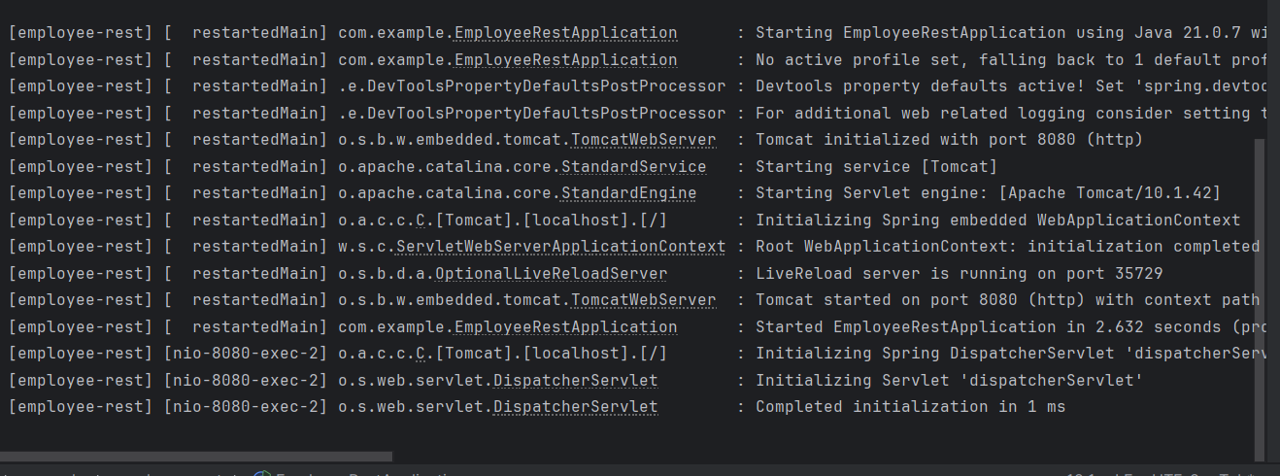

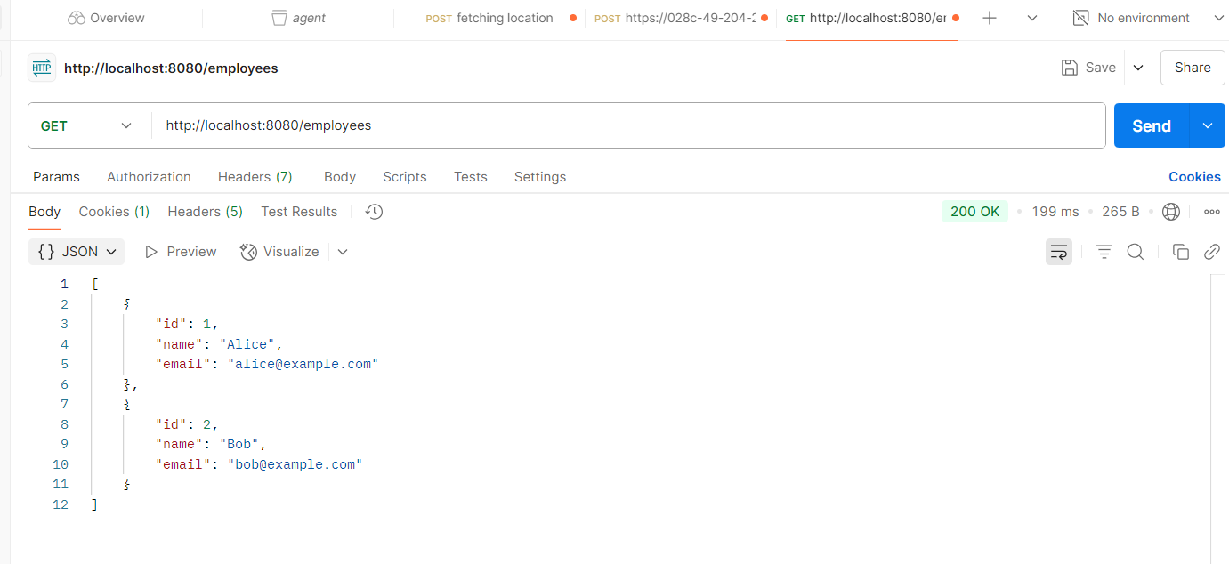

**4.Create REST service for department**

**DepartmentController**

package com.example.controller;

import com.example.model.Department;

import com.example.service.DepartmentService;

import org.slf4j.Logger;

import org.slf4j.LoggerFactory;

import org.springframework.web.bind.annotation.*;

import java.util.List;

@RestController

public class DepartmentController {

private static final Logger logger = LoggerFactory.getLogger(DepartmentController.class);

private final DepartmentService departmentService;

public DepartmentController(DepartmentService departmentService) {

this.departmentService = departmentService;

}

@GetMapping("/departments")

public List<Department> getAllDepartments() {

logger.info(" Department REST service called");

return departmentService.getAllDepartments();

}

}

**DepartmentDao**

package com.example.dao;

import com.example.model.Department;

import org.springframework.beans.factory.annotation.Autowired;

import org.springframework.stereotype.Repository;

import java.util.ArrayList;

import java.util.List;

@Repository

public class DepartmentDao {

public static List<Department> DEPARTMENT_LIST;

@Autowired

public DepartmentDao(List<Department> departmentList) {

DEPARTMENT_LIST = new ArrayList<>(departmentList);

}

public List<Department> getAllDepartments() {

return DEPARTMENT_LIST;

}

}

**Department**

package com.example.model;

public class Department {

private int id;

private String name;

public int getId() {

return id;

}

public void setId(int id) {

this.id = id;

}

public String getName() {

return name;

}

public void setName(String name) {

this.name = name;

}

}

**DepartmentService.java**

package com.example.service;

import com.example.dao.DepartmentDao;

import com.example.model.Department;

import org.springframework.stereotype.Service;

import java.util.List;

@Service

public class DepartmentService {

private final DepartmentDao departmentDao;

public DepartmentService(DepartmentDao departmentDao) {

this.departmentDao = departmentDao;

}

public List<Department> getAllDepartments() {

return departmentDao.getAllDepartments();

}

}

